**PAS**

**To:** Dr. Matt Bohm

**From:** PAS

**Project:** Plasma Arc Speaker

**Subject:** Concept Variant 2

**Date:** March 4, 2011

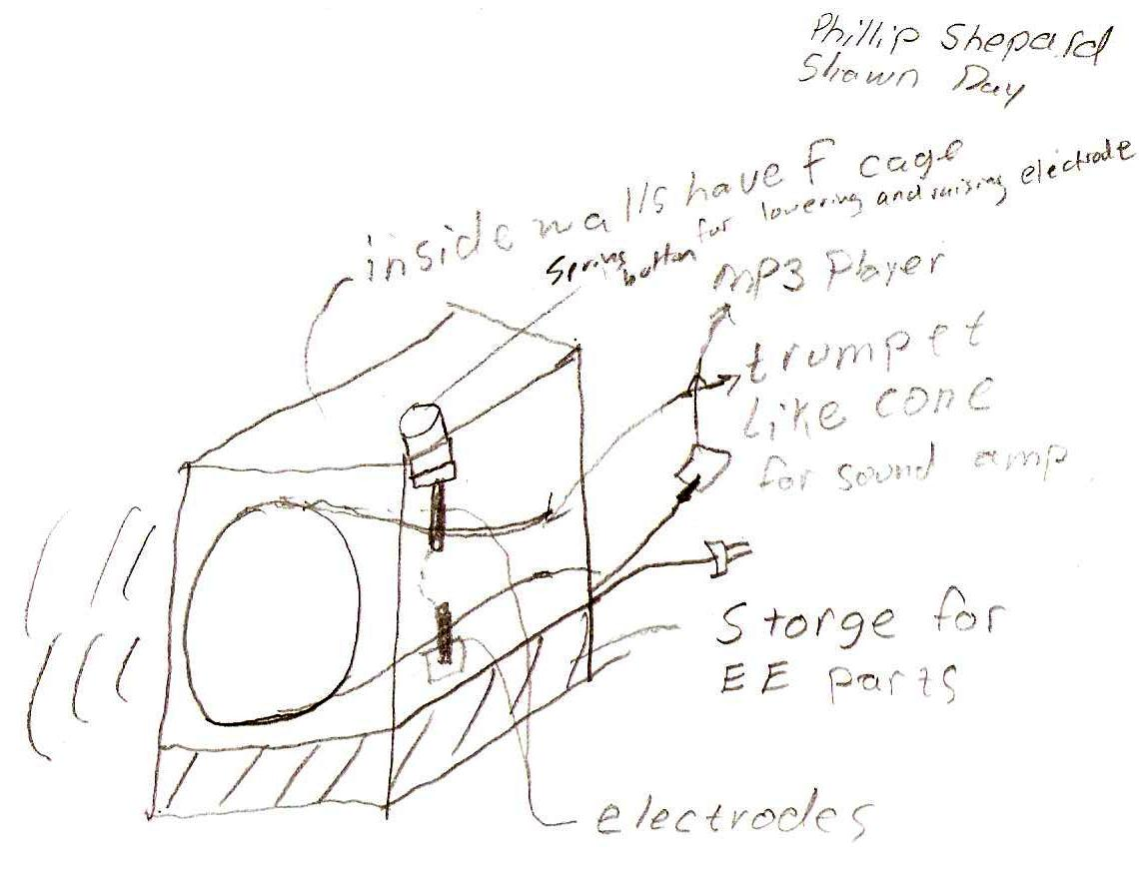

CV 2 is a box with a cone inside to amplify sound in one direction. The electrodes extend vertically through the backside of the cone. The box has a Faraday cage inside, but the cone opening is not covered with the cage to keep the plasma arc viewable.  The electrical components will be located in the bottom housing. A spring is connected to the top electrode with a button on top of the spring for lowering and raising the electrode.